

Original Article format

Title page:
Title:
Titles should be statements that summarize the main finding of the study (basically identical to the last sentence of the conclusion at the end of the discussion).
Ultrashort titles are discouraged, please make sure that all important keywords are present in the title.

Authors:
Recall international standards which contribution qualifies for authorship.

Affiliations:

Correspondence to:

Word count (maximum 3500):
Number of figures, tables, boxes, references (maximum 50 references):
Running head:

Graphical abstract illustrating main result using this template:
(It is essential to be concise, the graphical abstract should form a simple, visual summary of the single main focus and finding of the article, and should not attempt to convey multiple results or complex methodological details.)
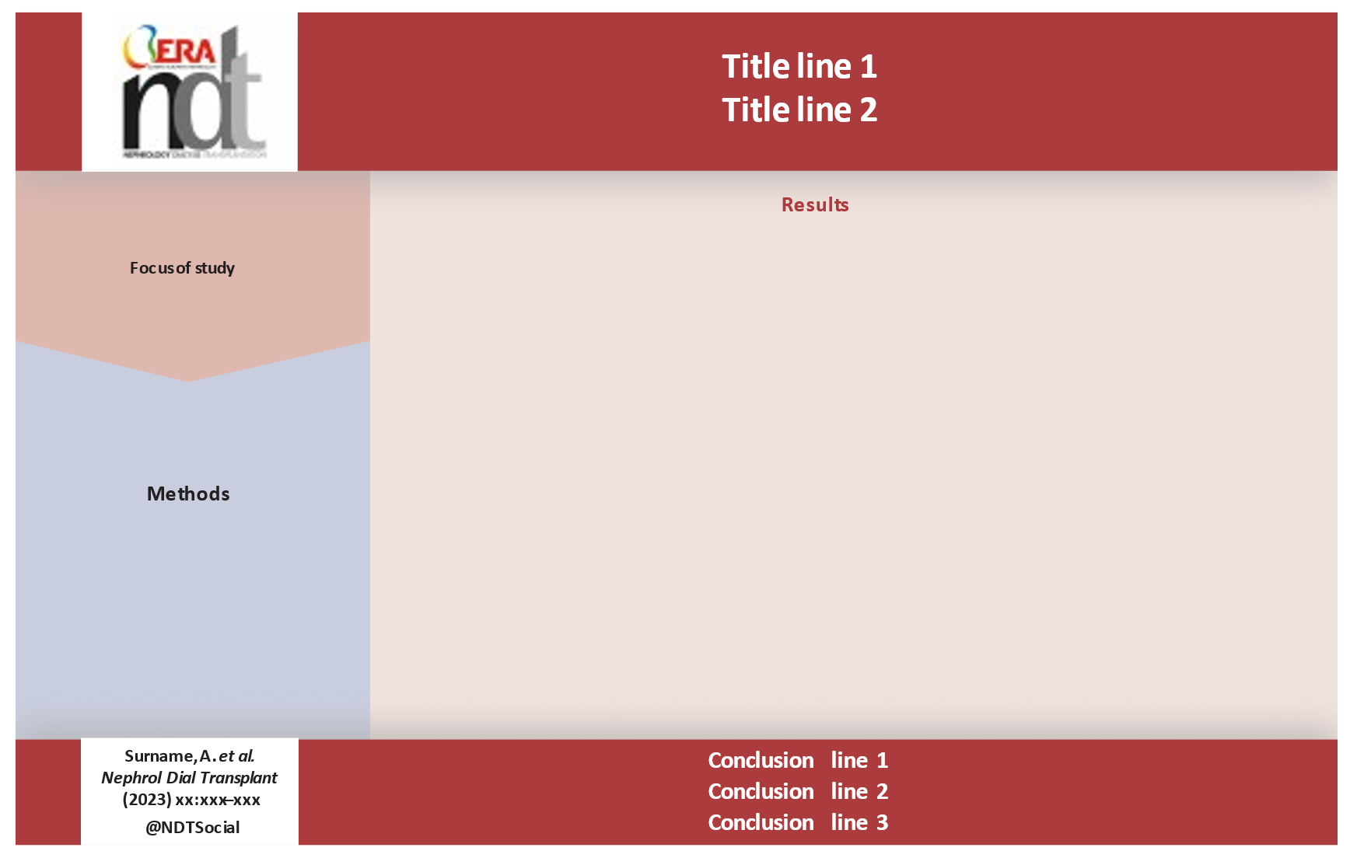

Abstract (maximum 300 words, structured)
Background and hypothesis.
(The hypothesis should be a statement that can be either verified or falsified.)

Methods.

Results.

Conclusion.

Key learning points
What was known (maximum 50 words):

This study adds (maximum 50 words):

Potential impact (on practice or understanding, maximum 50 words):

Keywords (maximum 5 in alphabetical order):

Introduction
Start the introduction with the wider context, epidemiology and unmet need.
End the introduction with your hypothesis. A hypothesis is a statement that can be either verified or falsified.
The hypothesis usually mirrors the title and the conclusion, i.e., the last sentence of the discussion to form the red line across the different parts of the manuscript. This is true even if the results of the study falsify the hypothesis.

Materials and Methods
List here the experimental design, resources used, and ethical permissions obtained. Reviewers should be able to understand whether the design of the study was appropriate to test the hypothesis.
Use the online supplement file to report trial protocols or extensive descriptions of the experimental methodology that help assure reproducibility of the experiments, e.g., tables with primer sequences.

Make sure that methods‘ reporting includes all information recommended for your type of study by the respective guideline (CONSORT, ARRIVE, STROBE, STARD, PRISMA, SQUIRE, CHEERS, SPIRIT, etc).
https://www.equator-network.org/reporting-guidelines/

Results
Use subheadings to structure data reporting.
Clinical studies may use formal headlines such as „Patient characteristics“, „Primary endpoints“, „Secondary endpoints“, „Safety analysis“, etc.
Experimental studies should use statement headlines, where the statement mirrors the conclusion of the respective paragraph, so that reading all results‘ headlines makes the flow and tells the story of the set of experiments and analyses.

Discussion
1. Paragraph: Start the discussion by repeating your hypothesis „We had hypothesized …“ Name the main findings of your results and indicate an interpretation.
Following paragraphs: Devote one paragraph to each of your main observations and discuss them in light of the existing literature.
Limitations paragraph: Name limitations of your study.
Last paragraph: Summarize once more the most important findings. Separate from that, indicate conclusions (and a future perspective). The ultimate conclusion should be more or less identical to the title of the manuscript.

Data availability statement:

Acknowledgements:

Funding:

Authors‘ contributions:

Conflict of interest statement:

References (maximum 50):

Tables + table legends:

Figures + figure legends:

